GROUND FLOOR PLAN
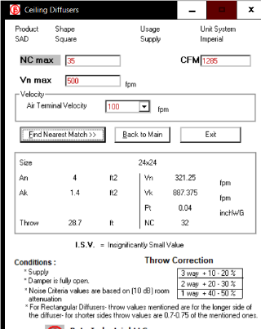

ADMINISTRATION
Ton = 2.6
Cfm=1285
No of Diffusers = 1
Diffuser Size = 600 x 600 mm
FLXØ550mm Type

OFFICE
Ton = 0.82
Cfm=404
No of Diffusers = 1
Diffuser Size = 300 x 300 mm
FLXØ250mm Type

DIRECTOR / CEO
Ton = 1.42
Cfm=694
No of Diffusers = 2 = 694/2 = 347
Diffuser Size = 300 x 300 mm
FLXØ250mm Type

OFFICE ACCOUNT
Ton = 1.274
Cfm=623
No of Diffusers = 2 = 625/2 = 312
Diffuser Size = 300 x 300 mm
FLXØ250mm Type

OFFICE 01
Ton = 0.3
Cfm=153
No of Diffusers = 1
Diffuser Size = 300 x 300 mm
FLX250mm Type

MEETING
Ton = 2.143
Cfm=1048
No of Diffusers = 3 = 1048/3 = 349
Diffuser Size = 300 x 300 mm
FLXØ250mm Type

RESTAURANT
Ton = 13.6
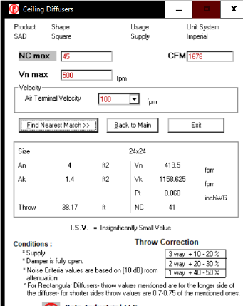
Cfm=6164
No of Diffusers = 4 = 6164/5 = 1233
Diffuser Size = 600 x 600 mm
FLXØ550mm Type

VIP LOUNGE
Ton = 6.6
Cfm=3356
No of Diffusers = 2 = 3356/2 = 1678
Diffuser Size = 600 x 600 mm
FLXØ550mm Type

VIP CHAMBER 01
Ton = 1.2
Cfm=602
No of Diffusers = 1
Diffuser Size = 450 x 450 mm
FLXØ400mm Type

VIP CHAMBER 02
Ton = 1.7
Cfm=870
No of Diffusers = 1
Diffuser Size = 450 x 450 mm
FLXØ400mm Type

WC NORTH
EX-CFM = 50
No of Disc Valve = 3
Total Passage Area = 100 ft²
No of Disc Valve = 2
Each Disc Valve Cfm = 50
Total EX-CFM = 150+100 = 250
FLXØ150mm Type

WC SOUTH
EX-CFM = 50
No of Disc Valve = 3
Total Passage Area = 119 ft²
No of Disc Valve = 2
Each Disc Valve Cfm = 60
Total EX-CFM = 150+120 = 270
FLXØ150mm Type

MALE WC
EX-CFM = 50
No of Disc Valve = 1
Total Passage Area = 118 ft²
No of Disc Valve = 2
Each Disc Valve Cfm = 60
Total EX-CFM = 50+120 = 170
FLXØ150mm Type
FEMALE WC
EX-CFM = 50
No of Disc Valve = 5
Total Passage Area = 60 ft²
No of Disc Valve = 1
Each Disc Valve Cfm = 60
Total EX-CFM = 250+60 = 310
FLX150mm Type
GRAND TOTAL EX-CFM = 170+310 = 480

KITCHEN HOOD VENTILATION
Kitchen Area = 5.7m x 6.8m
Ex-Cfm = 1200 X 990/1000 = 1188
Ex Duct Size =425W x300H
Total Ex-Cfm = 2 x Ex-Cfm = 2 x 1188 = 2376
Main Duct Size = 550W x 400H
FRESH AIR = 80%
Fresh Air Cfm = 0.8 x 2376 = 1900
FA Duct Size = 450W x 400H
Grill Size = 2000L x 200H x 40T (8-inch Height)

FIRST FLOOR PLAN
MAIN HALL
Ton = 75.5
Cfm=31063
Zone 01 = Main Hall & Excluding Balcony
Zone 02 =Below Balcony Area & Projection Room(278Cfm)
No of Machines = 2 AHU (Each 32.08 Tr, it covers main hall)
= 2 FCU (FCU04A 5.7 Tr & FCU04B 5.8 Tr, it covers below Balcony area & Projection room)
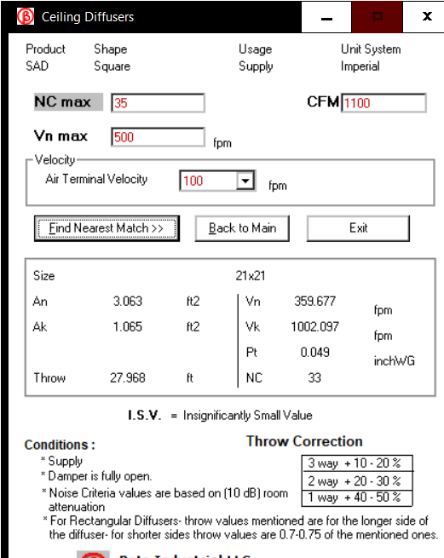
Zone 01
No of Supply Diffuser & Grill = 28 = 30785/28 = 1100
Diffuser Size = 550 x 550mm
Linear Supply Grill Size = 1000L x 250H 50W mm
Linear Return Grill Size = 1500L x 250H 50W mm (18nos of Each Cfm = 1710)
Zone 02
FCU04A = 2200 Cfm
FCU04B = 2487 Cfm
No of Grill = 6 = 4400/6 = 1100
Diffuser Size = 550 x 550mm
FLXØ500mm Type
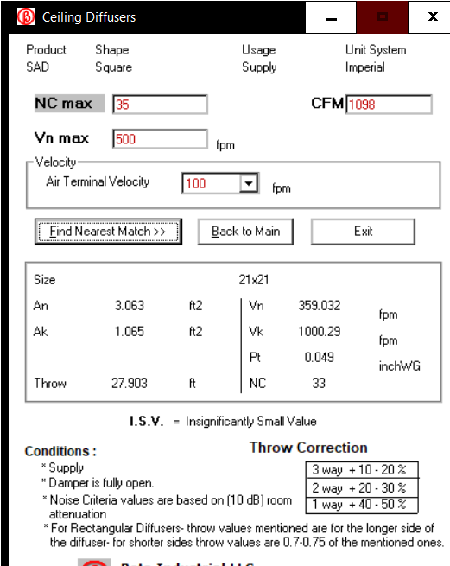
Total Fresh Air Required = FA-CFM = 1785
Projection Room
Diffuser cfm = 278
Diffuser Size = 250 x250mm
FLX200mm type

HALL 01
Ton = 17.8
Cfm=8787
No of Diffusers = 8 = 8787/8 = 1098
Diffuser Size = 550 x 550mm
FLXØ500mm Type

MEETING HALL & MULTIPURPOSE HALL
Ton = 10.8
Cfm= 4242
No of Diffusers = 4 = 4242/4 = 1081
Diffuser Size = 550 x 550mm
FLXØ500mm Type
Ton = 13.8
Cfm= 5549
No of Diffusers = 6 = 45549/6 = 925
Diffuser Size = 450 x4550mm
FLXØ400mm Type

MALE WC
EX-CFM = 50
No of Disc Valve = 5
Total Passage Area = 288 ft²
No of Disc Valve = 5
Each Disc Valve Cfm = 58
Total EX-CFM = 250+288 = 538
FLXØ150mm Type
FEMALE WC
EX-CFM = 50
No of Disc Valve = 6
Total Passage Area = 125 ft²
No of Disc Valve = 3
Each Disc Valve Cfm = 43
Total EX-CFM = 400+125 = 525
FLX150mm Type
GRAND TOTAL EX-CFM = 538+525 = 1063

MALE WC
EX-CFM = 50
No of Disc Valve = 2
Total Passage Area = 119 ft²
No of Disc Valve = 2
Each Disc Valve Cfm = 60
Total EX-CFM = 100+120= 220
FLXØ150mm Type
FEMALE WC
EX-CFM = 50
No of Disc Valve = 6
Total Passage Area = 174 ft²
No of Disc Valve = 2
Each Disc Valve Cfm = 87
Total EX-CFM = 400+174 = 474
FLX150mm Type
GRAND TOTAL EX-CFM = 219+474 = 693

SECOND FLOOR PLAN

BALCONY
Ton = 30.1
Cfm=10612
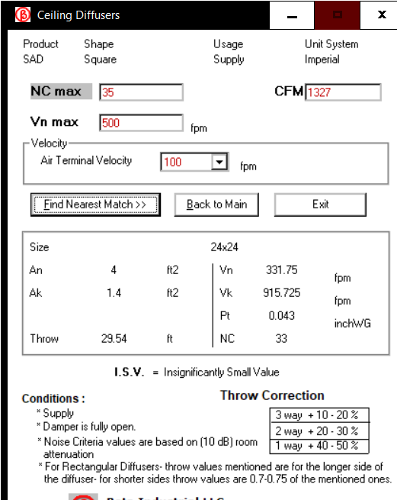
No of Diffusers = 8 = 10612/8 = 1327
Diffuser Size = 600 x 600mm
FLXØ550mm Type

MALE WC
EX-CFM = 50
No of Disc Valve = 2
Total Passage Area = 170 ft²
No of Disc Valve = 2
Each Disc Valve Cfm = 85
Total EX-CFM = 100+170= 270
FLXØ150mm Type
FEMALE WC
EX-CFM = 50
No of Disc Valve = 4
Total Passage Area = 125 ft²
No of Disc Valve = 2
Each Disc Valve Cfm = 62.5
Total EX-CFM = 200+125 = 325
FLX150mm Type
GRAND TOTAL EX-CFM = 270+325 = 595

